Longhoughton Community & Sports Center

Opening Instructions
- Use the code you have been given to get the keys out of the lockbox.
- Open the front door shutter and front door (all keys are labelled).
- Check that only the ‘Supply present’ light is illuminated on the Fire alarm panel. See photo 1.
- Turn on the entrance lobby and reception area lights if necessary.
- Go into the Community Wellbeing room and open the shutters. The key is kept permanently in position. See photo 2. The shutter in the Wellbeing room opens more quickly than the other shutters, so please allow an additional 4 seconds before returning the key to the mid position. Leave the Wellbeing room unlocked.
- Unlock the door at the end of the changing room corridor by turning the knob at the top of the door clockwise - this may need to be turned twice. Open the door and check that the handle on the outside will not turn. Use the key marked ‘Steel door’ to lock this if necessary.
- In Meeting Room 3 check the heating levels on both thermostats. These should be set to 20c if the room is to be used today, or 13c if not. See photo 3.
- In the Function Room open the shutters, the control is next to the left hand fire exit, and may be hidden by the curtain. See photo 4.
- Sweep the Function Room floor if necessary.
- In Meeting Room 1, open the shutter on the fire exit. See photo 5.
- Check that the heating thermostat is plugged in and switched on at the wall socket. Avoid touching the thermostat, as it is very sensitive and can change target temperature if touched, it does not need to be showing a temperature. See photo 6.
- Check that the toilets are in a clean condition & not blocked.
- Return the keys to the lockbox and randomise the combination.

1.
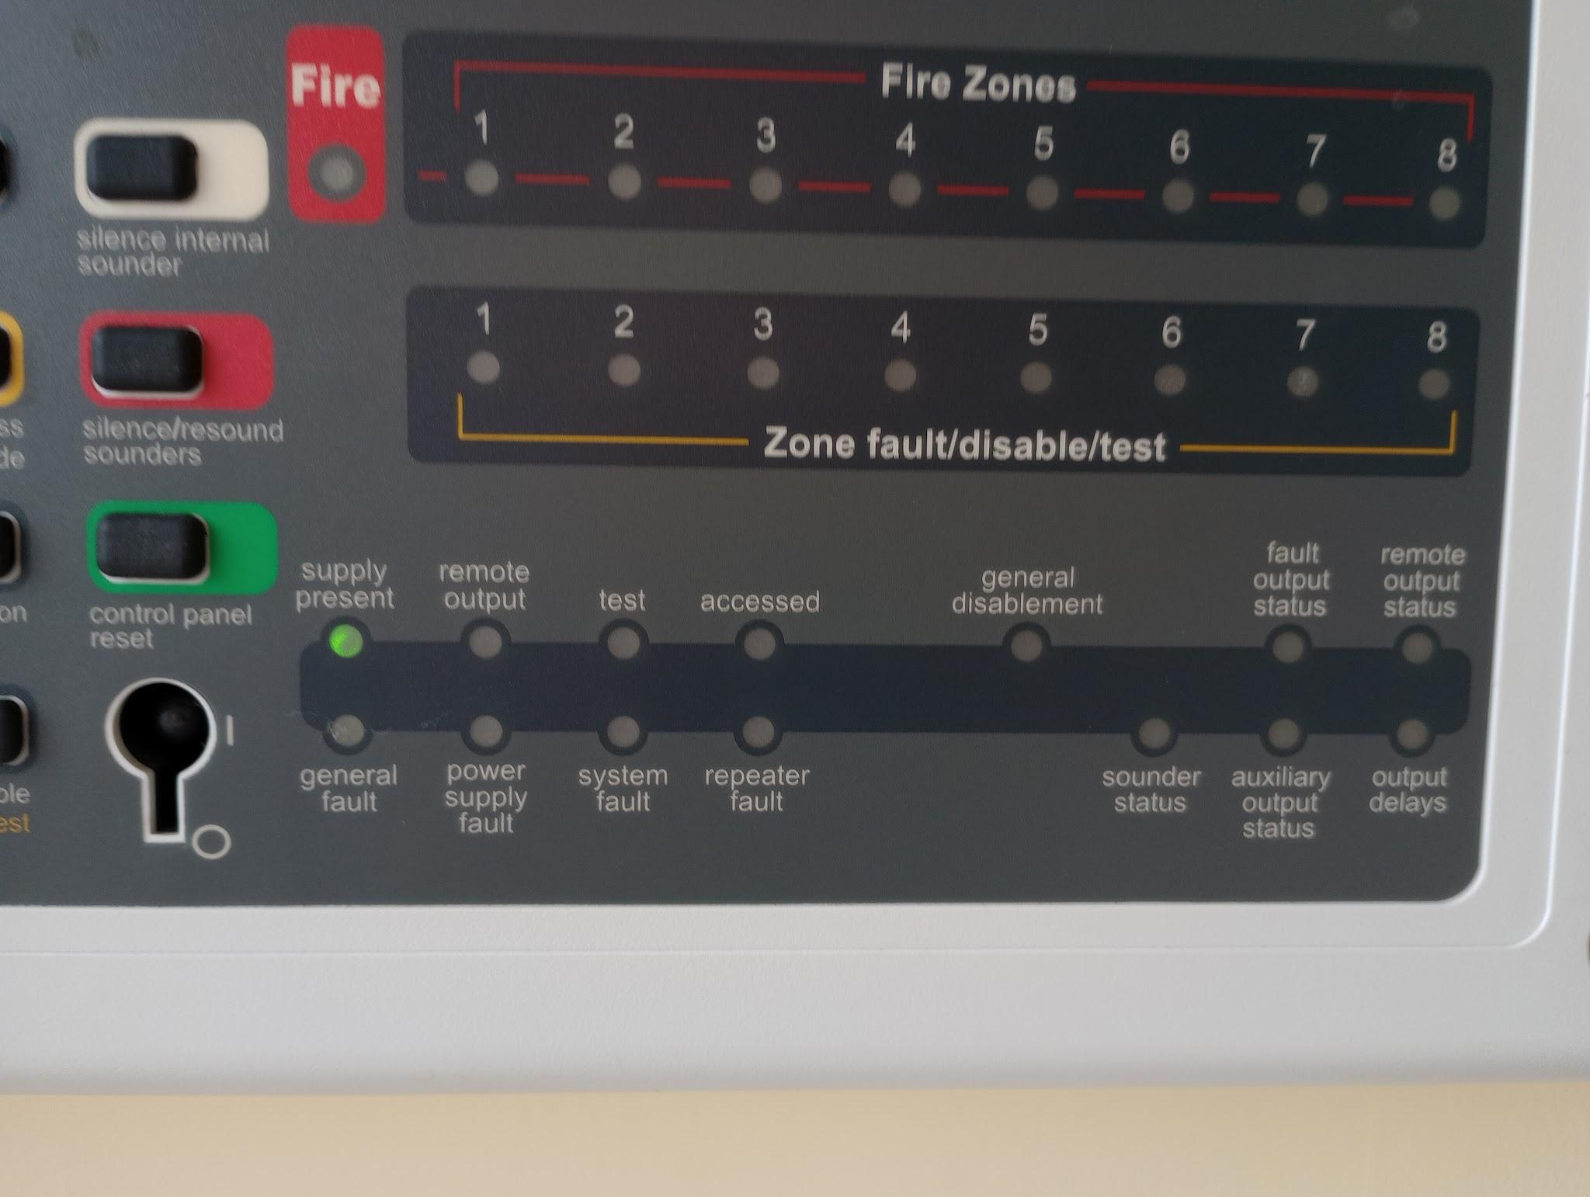
2.
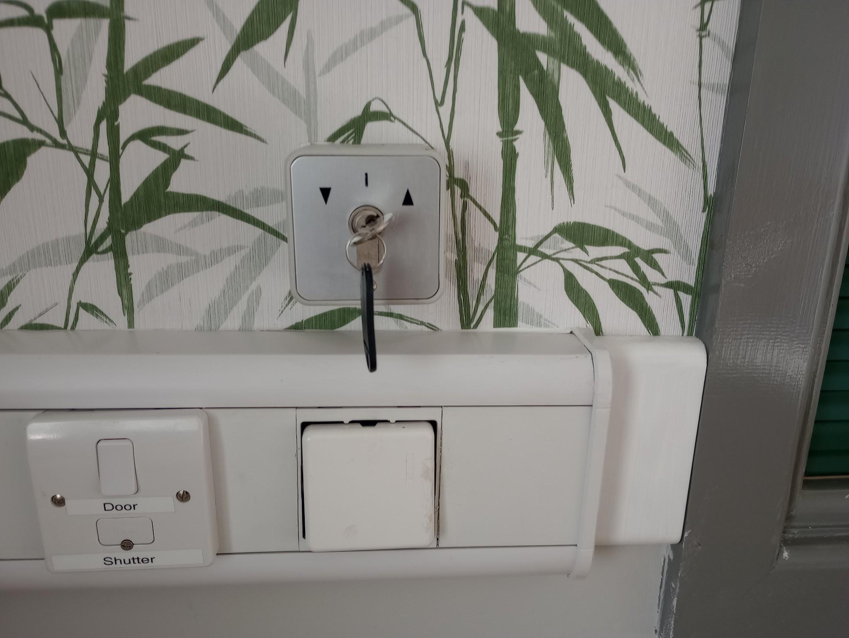
3.
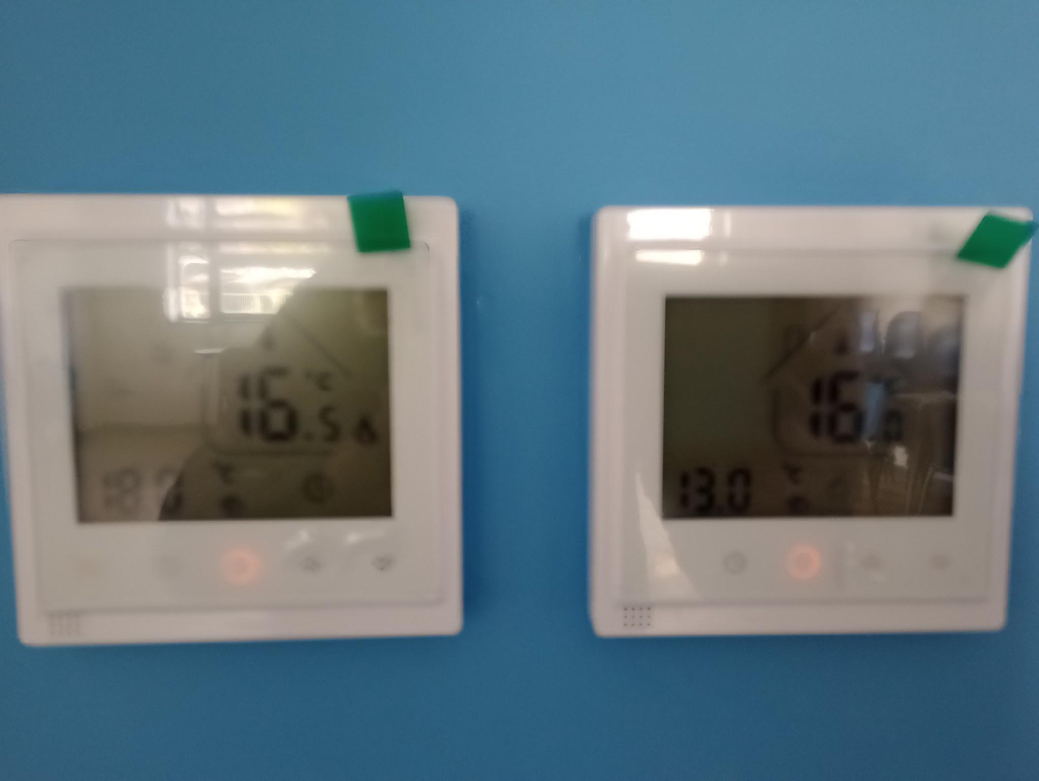

4.
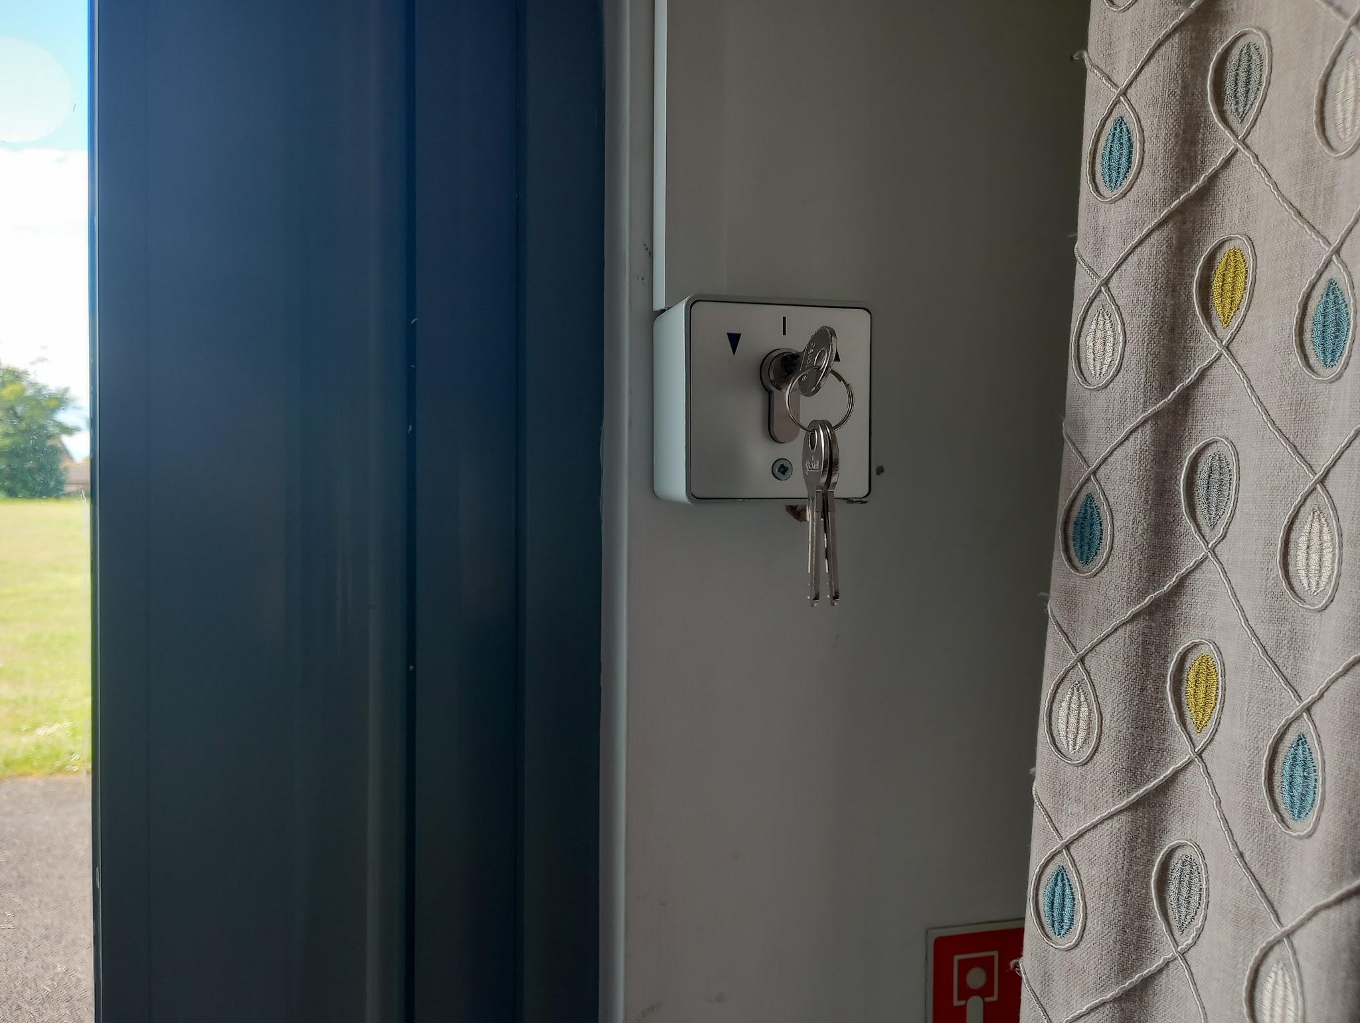
5.
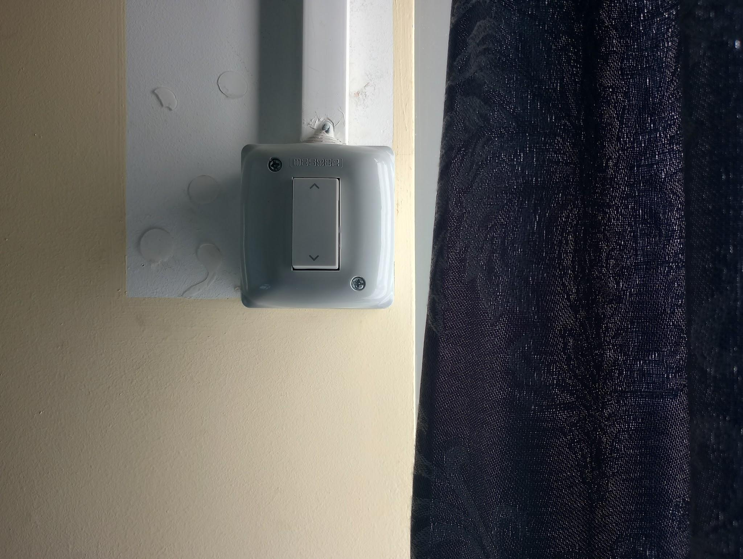
6.
