Longhoughton Community & Sports Center

Closing Instructions
- Use the code you have been given to get the keys out of the lockbox.
- Turn off all lights.
- Go into the Community Wellbeing room and close the shutters. The key is kept permanently in position. See photo 1. Leave the Wellbeing room unlocked.
- Open the door at the end of the changing room corridor and check that the handle on the outside will not turn. Use the key marked ‘steel door’ to lock this if necessary. Lock the door from the inside by turning the knob at the top of the door anti-clockwise.
- Check that the toilet lights and extractor fans are out in each of the main changing rooms. See photo 2. The changing area lights are on a motion sensor/timer and no action is required.
- In the corridor check that the switch for the fridge in the locked cupboard has been switched off. See photo 3.
- In Meeting Room 3 check the heating levels on both thermostats are set to 13c. See photo 4.
- Check that the fire exit door is latched closed and cannot be pushed open except by using the push bar. Ensure all the windows are closed.
- In the Function Room close the shutters, the control is next to the left hand fire exit, and may be hidden by the curtain. See photo 5.
- Check that the power supply to the AV unit is switched off at the wall in the chair store. See photo 6.
- Check all wall switches in the kitchen have been turned off.
- In Meeting Room 1, close the shutter on the fire exit. See photo 7. Check that the thermostat is plugged in and switched on.
- Lock the front door and lower the shutter.
- Lock the 3G pitch gate if unlocked.
- Return the keys to the lockbox and randomise the combination.

1.
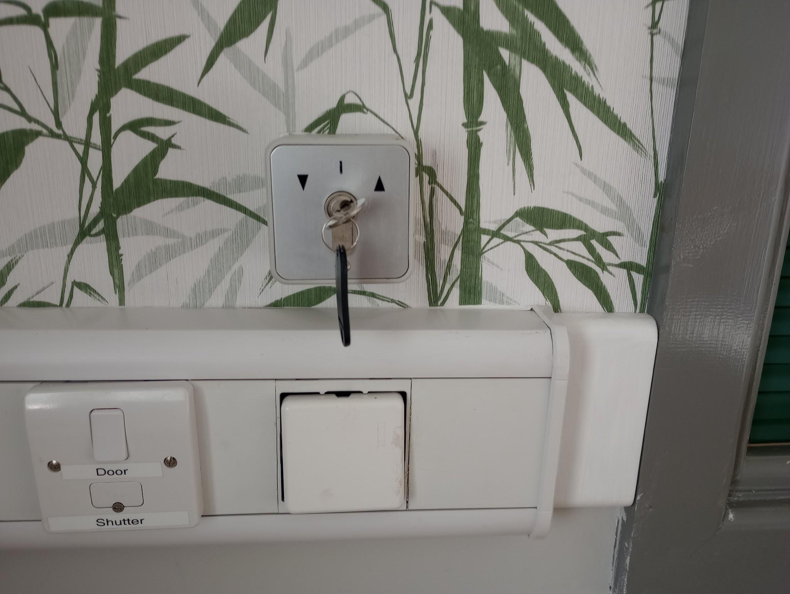
2.
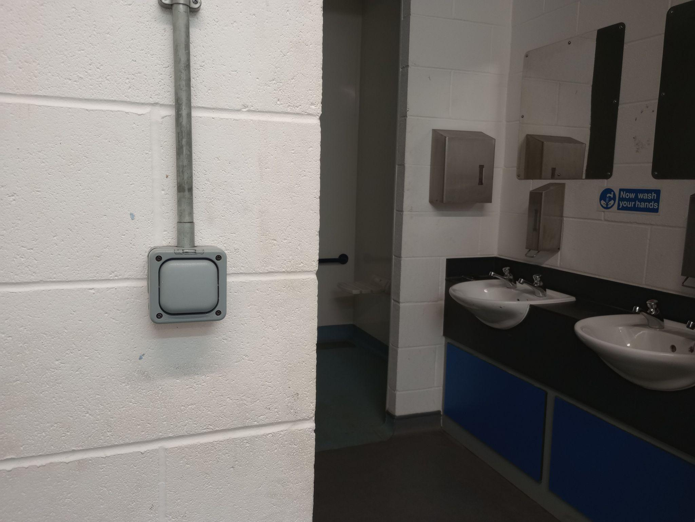
3.
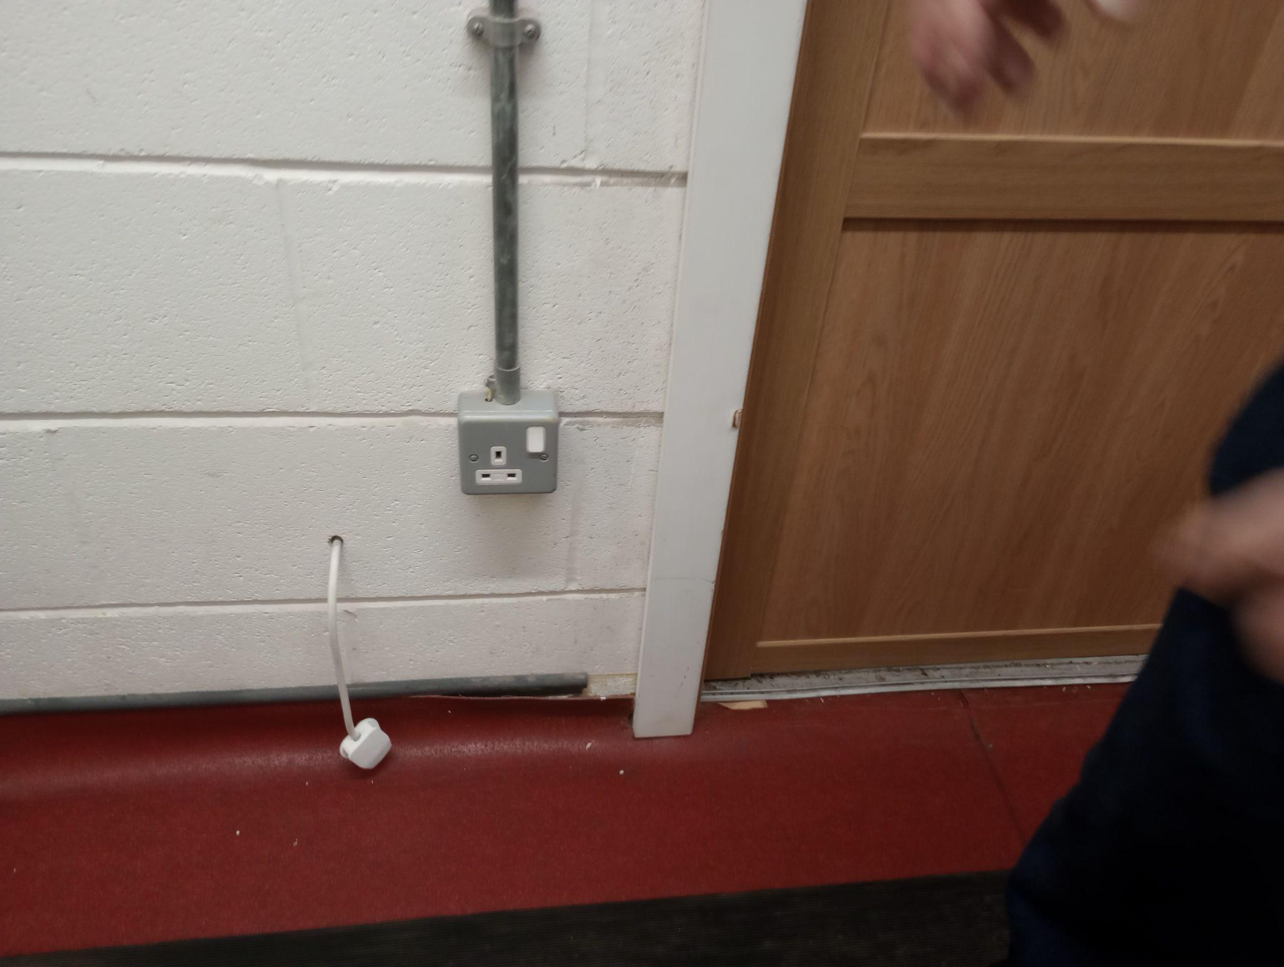

4.
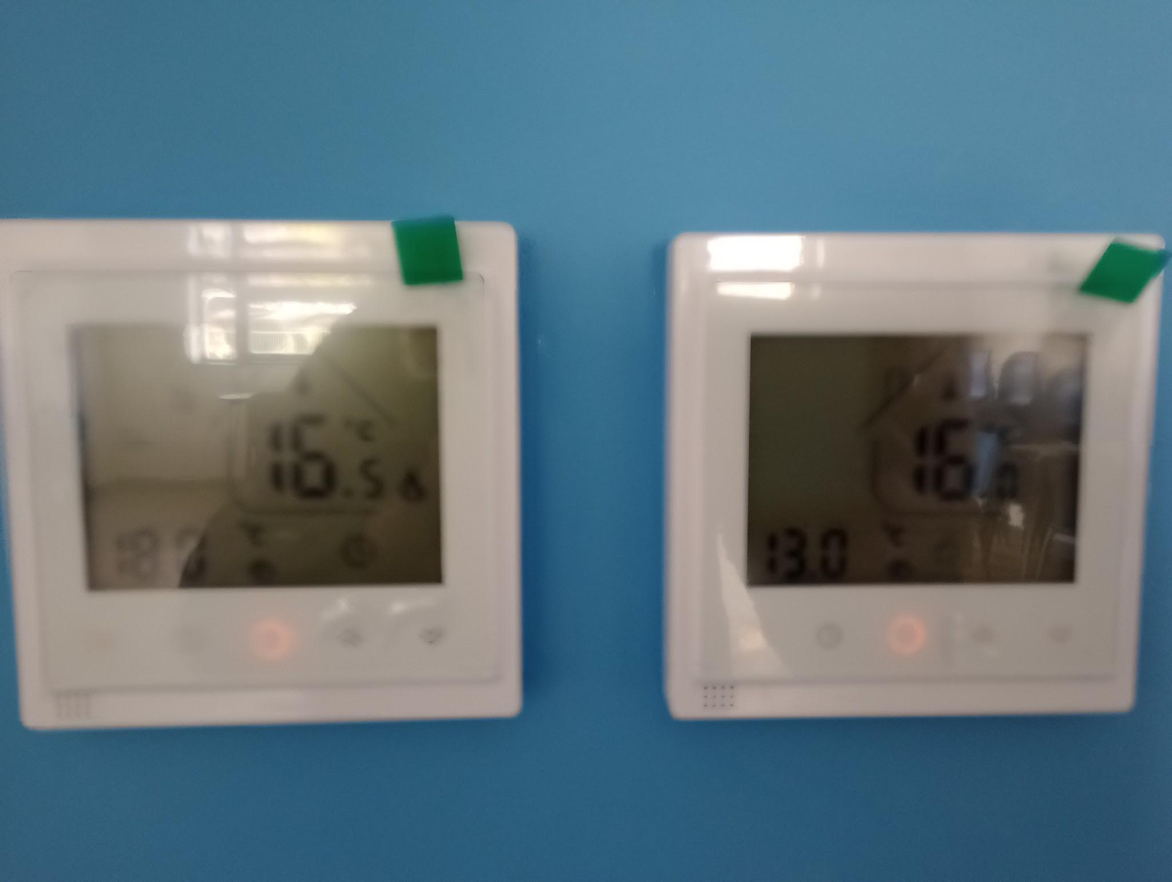
5.
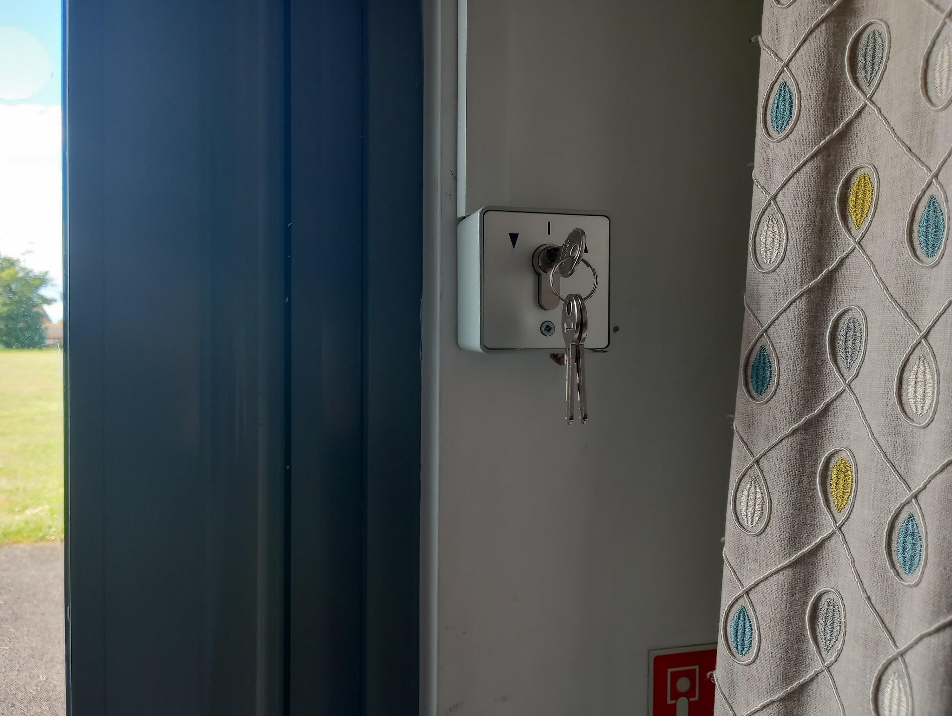
6.
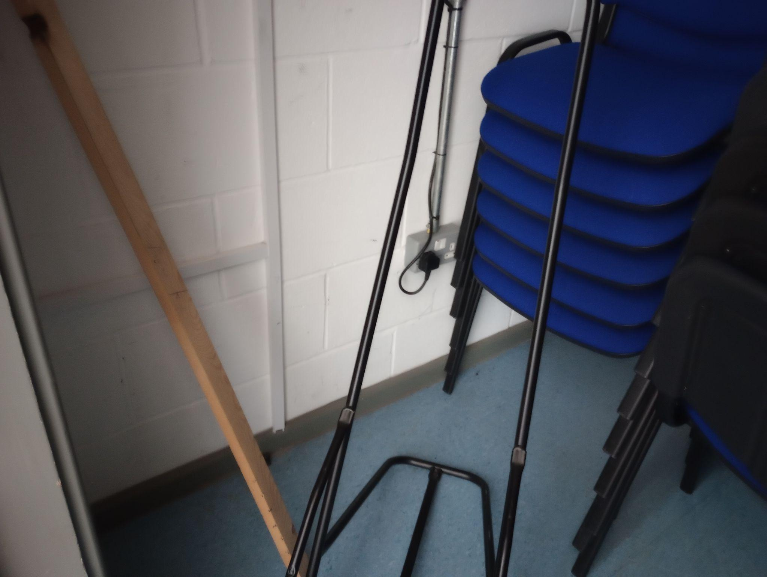
7.
