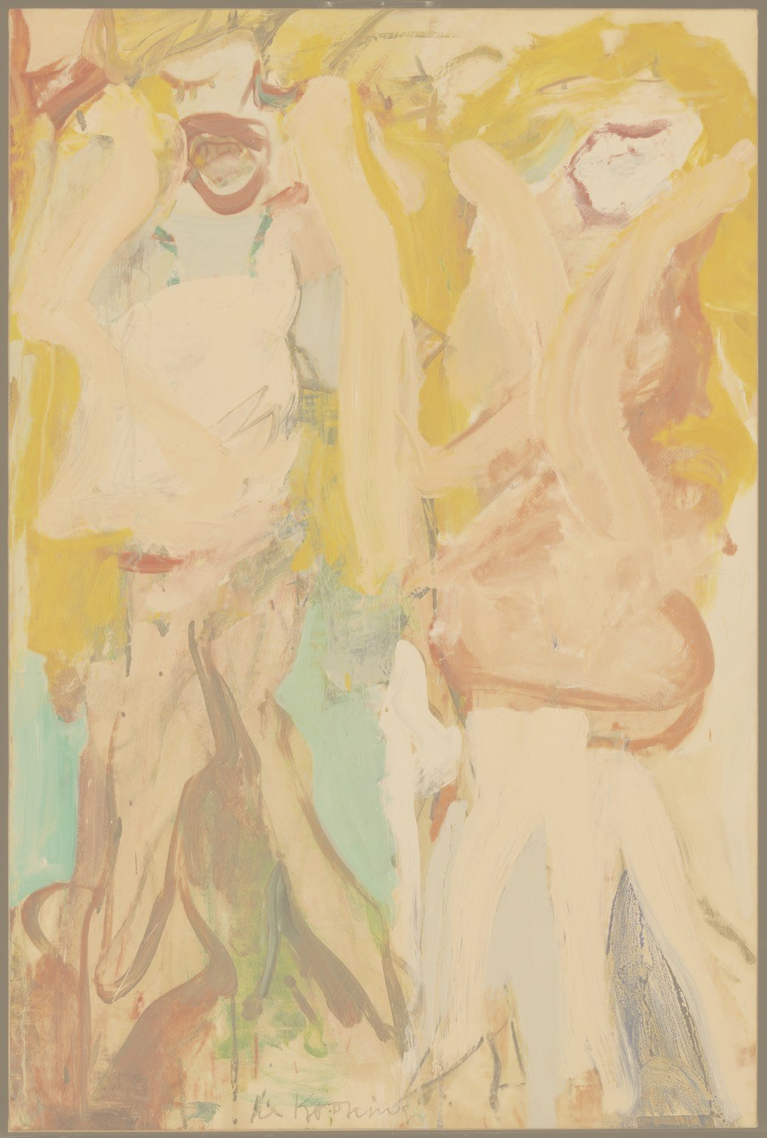

BREATHE…SING…RELAX…NURTURE

The Sunday Sessions

**Join musician and teacher Caro Fentiman**

**for singing workshops designed to offer a place for women to be nurtured and creative**

**This is an opportunity to make space for yourself, away from the daily stresses of your busy life.**

Singing workshops for women

**28th April, 2nd June, 7th July 2019**

**2.30-5.00pm**

**Longhoughton Community & Sports Centre NE66 3JH**

**Cost: £12.50 per session (£30 for three),**

**to include delicious homemade refreshments**

**Booking essential: contact Caro for more information or to reserve your place:**

[**carofentiman@gmail.com**](mailto:carofentiman@gmail.com) **07932 746326**